Registration


Please complete both sides,
detatch and
Return by July 25th
Name:_________________________
Address:
______________________________
______________________________
Phone: ________________________
E-mail:________________________
Others in Foursome:
(2)____________________________
(3)____________________________
(4)____________________________
We will be happy to accommodate your request for playing partners or to place single entrants into foursomes.



For the past 19 years, the St Thomas UCC golf tournament has been a cherished tradition, bringing together community members and golf enthusiasts. Over the years, this event has successfully raised over $144,00, demonstrating the incredible generosity and support of its participants. The funds raised through this tournament are dedicated to the St Thomas UCC building fund, ensuring the church can continue to serve the congregation and community while maintaining the facilities.

St Thomas UCC is deeply committed to support the community through various ministry and outreach services. These initiatives include providing assistance to those in need, organizing community events, and offering youth programs. By participating in the golf tournament, you are directly contributing to these vital services, helping St Thomas UCC make a positive impact on the lives of many individuals and families.

For more information about St Thomas UCC and how you can get involved, please visit stthomasucc.net or call 717-652-7259. Your participation in the golf tournament and other church activities is greatly appreciated and plays a crucial role in sustaining the church’s mission and outreach efforts. Join us in making a difference and supporting a cause that truly matters.



Join us for
our
20th

Friday, August 7
2026
12:30 pm
Manada Golf Club

Tournament host:
St. Thomas United Church
of Christ

You are cordially invited…
to join us in the twentieth annual golf tournament to benefit the Capital Campaign and Building Maintenance of St. Thomas United Church of Christ.

Friday, August 7
Rain or Shine

Manada Golf Club
609 Golf Lane
Grantville, PA
(717) 469-2400

Schedule of Events
11:00 a.m. Registration
& Luncheon
12:30 p.m. Shotgun Start
Scramble Format
5:30 p.m. Pig Roast Dinner
& Awards

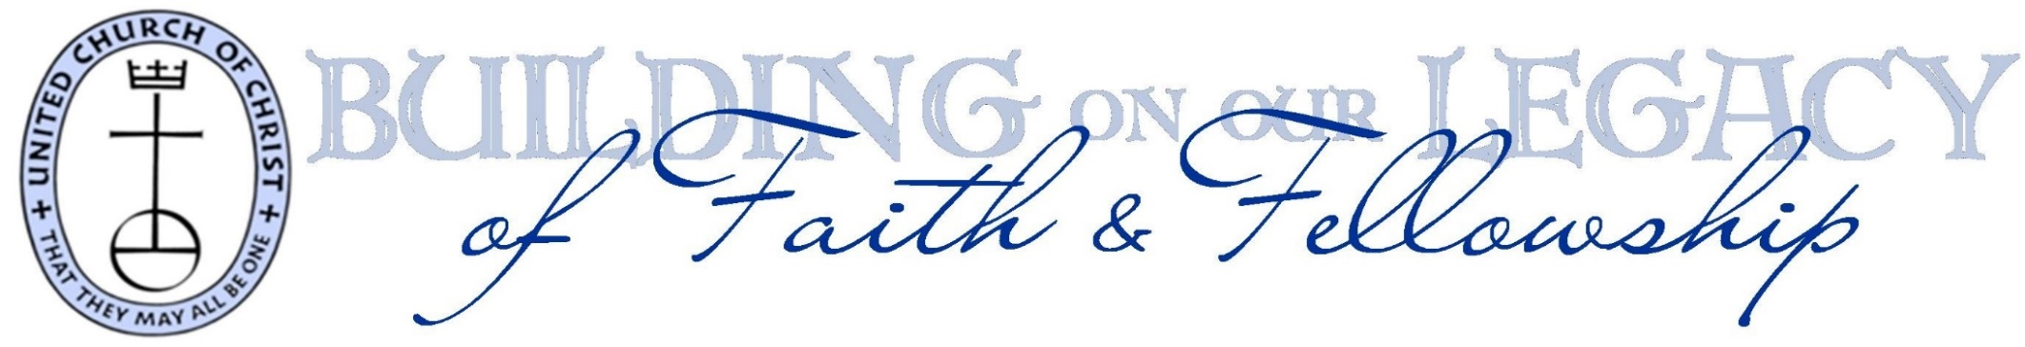
$90 Entry Fee Includes:
18 holes of golf w/cart
Luncheon
pig roast dinner
** Mr. Frosty for dessert**
skill & raffle prizes
$500 Corporate Sponsorship Includes:
all of the above for your foursome, AND
your company banner
displayed in the pavilion
$100 Hole Sponsor Fee:
your company sign at the tee of one of 18 holes
$30 Pig Roast Only
Encourage your spouse or friends to join you for dinner
Questions?
St Thomas UCC (717) 652-7259
Laurie Soles (717) 379-9457

Please detach,
complete both sides and
return by July 25th
 | Cost | Total
Individual Golf  Registration | $90 pp | $
Corporate  Sponsorship | $500 | $
Hole Sponsor | $100 | $
Pig Roast Only | $30 pp | $
Donation |  | $
TOTAL ENCLOSED |  | $

Please make checks payable to
St. Thomas United Church of Christ
c/o Paul Hepler
7223 Evergreen Lane
Harrisburg, PA 17112

